Profile of Dr. S. Savitha
Vice Principal (Academics), Sacred Heart College, Tirupattur

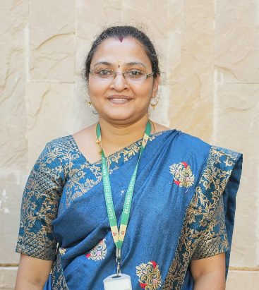 | Name: Dr. S. Savitha  Current Position: Vice Principal (Academics), Sacred Heart College, Tirupattur  Experience: 14+ years of teaching

Academic Qualifications
• Ph.D. in Mathematics – Research on 'A Study on Multivariate Stochastic Models on the Growth of Tumor Cells Under Oncolytic Virotherapy'
• M.Phil. in Mathematics
• M.Sc. in Mathematics
• B.Sc. in Mathematics
• Bachelor of Education (B.Ed.)
• Diploma in Art Therapy
Professional Experience
• 14+ years of teaching experience at Sacred Heart College
• Vice Principal (Academics) – Managing academic strategy and institutional excellence
• Dean of Women Students – Served multiple terms, promoting student welfare and empowerment
• Head of the Department (Mathematics) – Led academic initiatives and departmental growth
Research & Academic Contributions
• Published 5 research papers in national and international journals
• Active participant in conferences, seminars, and workshops
• Expertise in mathematical modeling applied to biomedical sciences
Areas of Specialization
• Functional Equations
• Mathematical Modeling
• Stochastic Processes
• Statistics
• Cryptography
• Number Theory
Additional Contributions
• Certified in Art Therapy – Promoting holistic education and student well-being
• Served as Resource Person for training students in Aptitude Skills
• Strong student mentoring and guidance record
Professional Strengths
• Strong academic leadership
• Innovative teaching methodologies
• Interdisciplinary approach to research and education
• Commitment to student-centered learning and holistic development
Inspiration
Dr. S. Savitha exemplifies academic excellence, compassionate mentorship, and visionary leadership. Her contributions to mathematics education and student development make her a highly respected academic professional and a source of inspiration to faculty and learners alike.

